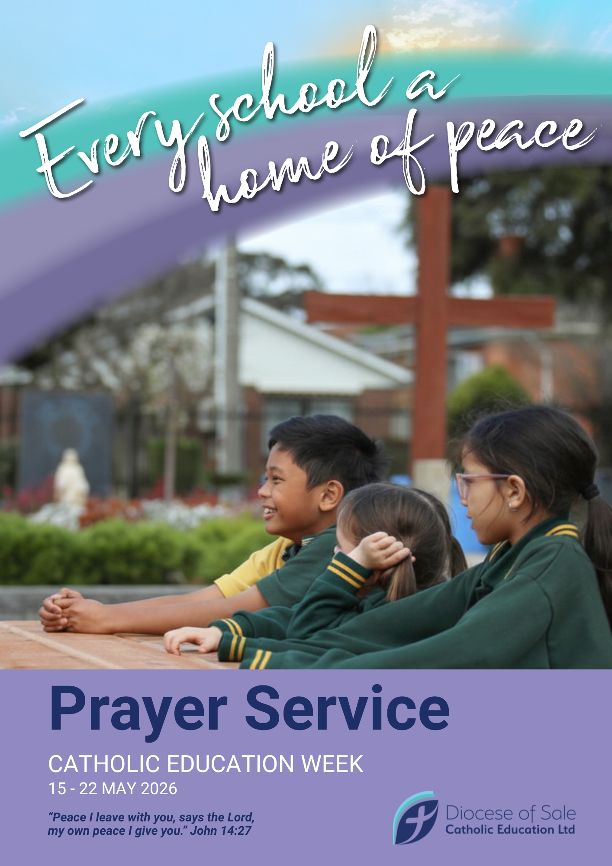



Preamble

Pope Leo XIV speaks of peace as both a gift from God and a human activity and advocates for schools to be ‘homes of peace’ by fostering humility, dialogue, and reconciling knowledge with meaning, competence with responsibility, and faith with life. He calls for an education that unites knowledge with responsibility, rejecting violence, promoting human dignity and building a future where love and understanding triumph. Education must draw from Gospel teachings on humility and encounter and address the whole person, integrating faith, knowledge, and responsibility and fostering consciences that choose right over advantage.

The relationship with Christ calls on us to develop a pastoral focus on the theme of peace. Indeed, the Lord sends us into the world to bring his same gift: “Peace be with you!”, and to become its creators in everyday life. I am thinking of parishes, neighbourhoods, areas within the country, the urban and existential peripheries. There, where human and social relationships become difficult and conflict takes shape, perhaps subtly, a Church capable of reconciliation must make herself visible. The apostle Paul urges us, “If possible, on your part, live at peace with all” (Rm 12:18); it is an invitation that entrusts a tangible portion of responsibility to every person. I hope, then, that every diocese may promote pathways of education in non-violence, mediation initiatives in local conflicts, and welcoming projects that transform fear of the other into an opportunity for encounter. May every community become a “house of peace”, where one learns how to defuse hostility through dialogue, where justice is practiced and forgiveness is cherished. Peace is not a spiritual utopia: it is a humble path, made up of daily gestures that interweave patience and courage, listening and action, and which demands today, more than ever, our vigilant and generative presence…The proclamation of the Gospel, peace, human dignity, dialogue: these are the coordinates through which you can be a Church that incarnates the Gospel and is a sign of the Kingdom of God. (Pope Leo, Address to the Italian Bishops’ Conference, 17/6/25)

Schools are not merely buildings where facts are delivered; they are homes of peace—places where young people learn to live together with dignity, curiosity, and mutual care. Educators, families, and communities are invited to imagine every school as a domestic space of belonging: a place where safety, respect, and hope are practiced daily and where the habits of peaceful life are intentionally formed.
Peace in schools is active and practical. It shows up in the routines that welcome students each morning, in classrooms that promote opportunities for authentic dialogue, in restorative responses to harm, and in curricula that teach empathy alongside literacy.

A Catholic school’s claim that every school is a home of peace rests on the conviction that education is a vocation of formation in the image of Christ. Peace is not merely the absence of conflict but the fruit of justice, mercy, and reconciliation; schools become homes of peace when their routines, symbols, and relationships make those virtues visible and teachable. Prayer, sacramental life, and communal rituals (gathering, blessing, sharing meals) shape a domestic culture where students learn to see one another as persons created and loved by God.

We offer this theme as an invitation and a challenge: to treat every school day as an opportunity to teach peace, to be a place that models reconciliation, and to commit to the slow, patient work of forming young people who can imagine and build a more just life for all.

Prayer Service Suggestions

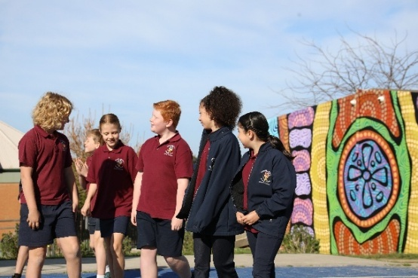
Leader: Let us acknowledge and pay our respects to the Traditional Custodians of the land across the Diocese where Aboriginal Nations have practised and celebrated learning for generations. The knowledge that has been shared has allowed for their cultures to thrive through their spiritual relationship with Country and ongoing connection to the land, seas, and waterways.
As we begin our prayer today, we ask Creator God to…
Bless this day:
all that we might see,
all that we might hear,
all that we might smell,
all that we might say.
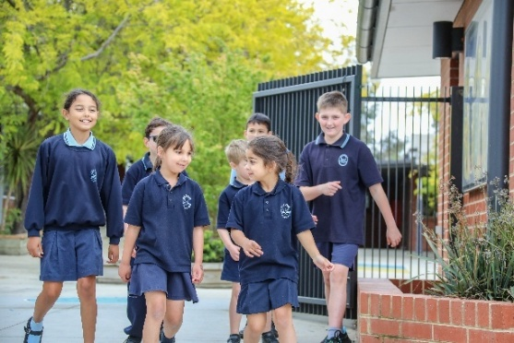
Bless this day:
all that we might serve,
all that we might comfort,
all that we might help,
all that we might guide.
Bless this day.
(Adapted from http://www.faithandworship.com)

Welcome and Introduction

Today we launch Catholic Education Week which, this year, has the theme of Every school a home of peace.
Catholic Education Week is a special week of celebration for all who work in Catholic education across The Diocese of Sale. There are 39 primary schools and seven secondary schools in the Diocese with two new primary schools to open in 2027. Collectively our schools support over 18,000 students and 2,900 school staff. This week, we join with Catholic schools across the Diocese as we focus on the theme of ‘Every school a home of peace’.
We are thankful for the gift of education, for our students, teachers, parents, priests and religious and all who support us in our faith and learning. May our Catholic schools continue to serve our families, our parishes, our communities and our country.
Let us begin our prayer in the name of the Father and of the Son, and of the Holy Spirit. Amen.

Please join in our gathering song.

Gathering Song Suggestions

- ‘Gather Together’ (John Burland, 1999 on Let’s Celebrate Too! or 2007 on Move! Pray! Celebrate!)
- Song of the Spirit (Drew Lane, 2020 on Song of the Spirit)
- ‘Gathered as One’ (John Burland, 2007 on Move! Pray! Celebrate! or 2005 on Lord Teach Me Your Ways)
- ‘We Come Together’ (John Burland, 1999 on Let’s Celebrate Too!)
- ‘Come Together’ (Michael Mangan, 2014 on 1,2,3 God Loves Me)
- ‘The House that Love is Building’ (Sarah Hart, 2020 on Love as Never Before)
- All are Welcome (All Belong) (Jesse Manibusan and Jennah Manibusan, 2016)

Opening Prayer

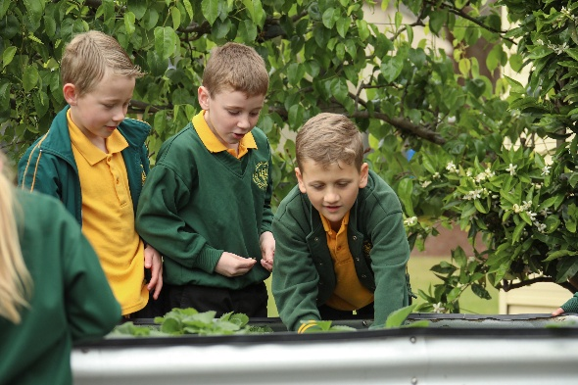
Leader: Pope Leo speaks of peace as both a gift of God and a human activity. Every school a home of peace challenges Catholic schools to build strong relationships and make Gospel hospitality, kindness, and Catholic Social Teaching the key principles of school life so that students learn to live with dignity, justice, and reconciliation. May we all, in our own way, bring this theme to life in our school and be a beacon of light and a bringer of peace to our community. We make this prayer through Christ, our Lord.

All: Amen.

Scripture
(Alternative Scripture texts can be found on pp. 9-10)

A Reading from the Holy Gospel According to John (14: 23-29)
Jesus said to his disciples:
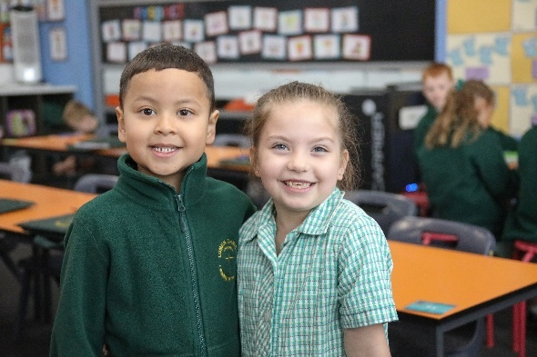
'If anyone loves me he will keep my word,
and my Father will love him,
and we shall come to him
and make our home with him.
Those who do not love me do not keep my words.
And my word is not my own;
it is the word of the one who sent me.
I have said these things to you
while still with you;
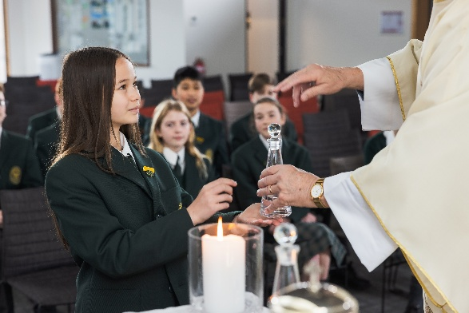
but the Advocate, the Holy Spirit,
whom the Father will send in my name,
will teach you everything
and remind you of all I have said to you.

Peace I leave with you,
my own peace I give you,
a peace the world cannot give, this is my gift to you.
Do not let your hearts be troubled or afraid.
You heard me say:
I am going away, and shall return.
If you loved me you would have been glad to know that I am going to the Father,
for the Father is greater than I.
I have told you this now, before it happens,
so that when it does happen you may believe.
'The Gospel of the Lord.
All: Praise to you, Lord Jesus Christ.

Pause for personal reflection: What are these words making you think about? What stands out for you? What message do you take away from this text? What wonderings do you have about this text?

Gospel Reflection

What does it mean that Jesus will make his home with us?
Think about your favourite place at home where you feel safe—maybe your bed, the kitchen table, or a cosy corner. Jesus is saying he wants to be with us in the same way: close, loving, and always ready to help. When we follow Jesus’ words—being kind, honest, and forgiving—we are making room in our hearts for him to live there.

What is the peace Jesus gives?
This peace is not just being quiet. It is a calm and brave feeling inside that helps us when we are scared, sad, or angry. Jesus says this peace is different from what the world gives—it stays with us even when things are hard. The Holy Spirit helps us remember Jesus’ words and gives us courage to do what is right.

How can we live this peace at school and at home?
- Listen carefully when someone is talking.
- Say sorry and forgive when we hurt each other.
- Help someone who is lonely by inviting them to play or sit with you.
These small things are ways we keep Jesus’ words and let him live in our hearts.

OR
In this text, Jesus promises that those who love him will keep his word and that the Father and the Son will make their home with them. He also promises the Advocate—the Holy Spirit—who will teach and remind the disciples of Jesus’ words. This is not a distant theological idea but a promise of presence: God wants to live with us and guide us from within.
Jesus calls the Spirit the Paraclete—one who comes alongside to help, teach, and defend—and he gives his peace to the disciples, a peace that is not like the world’s (it is deeper and more lasting). This peace is a gift that steadies the heart when life feels chaotic; it is the Spirit’s work to remind us of Jesus’ way and to empower us to live it out.

OR
Listen to ‘Give Us Your Peace’ by Jesse Manibusan and Sarah Hart.

General Intercessions
(choose from the following or write your own)

Leader: Let us bring our needs before God, who is the source of all peace.

Reader 1: For the Church and its leaders, especially Pope Leo, Bishop Greg Bennet and the clergy and religious in our Diocese. May they inspire and support Catholic schools in forming communities of peace, reconciliation and hope. Lord, hear us.

All: Lord, hear our prayer.

Reader 2: For all involved in Catholic education in our Diocese, our students, staff and families; that our schools and offices will truly be places of peace, love, hope and joy. Lord, hear us.

All: Lord, hear our prayer.

Reader 3: For school principals, and leadership teams. May they lead with wisdom, justice, and a spirit of hospitality so every school truly becomes a home of peace. Lord, hear us.

All: Lord, hear our prayer.

Reader 4: For teachers and staff. May they be strengthened in patience, creativity, hope and compassion as they share the peace of Christ with their school community. Lord, hear us.

All: Lord, hear our prayer.

Reader 5: For our students. May they grow in empathy, courage, and the ability to nurture peace and resolve conflict with dignity and care for one another. Lord, hear us.
All: Lord, hear our prayer.

Reader 6: For all those who share the story of Jesus in our school and parish. May they continue to be blessed with inspiration and creativity. Lord, hear us.

All: Lord, hear our prayer.

Reader 7: For peace in our world and for all who work for peace. Lord, hear us.

All: Lord, hear our prayer.

Reader 8: For those experiencing extreme weather conditions and other natural disasters. May they be strengthened by our prayers and practical support. Lord, hear us.

All: Lord, hear our prayer.

Reader 9: For the care of creation. May our school community learn to live in right relationship with the earth and with one another as stewards of God’s gift. Lord, hear us.

All: Lord, hear our prayer.

Reader 10: For all gathered here and for those we carry in our hearts, that we may be sent forth as peacemakers, living the Gospel in word and deed. Lord, hear us.

All: Lord, hear our prayer.

Reader 11: For those in our school and parish communities who are experiencing illness, pain, grief, and sadness; and for those we love who have died (pause for a few seconds). Lord, hear us.

All: Lord, hear our prayer.

Leader: Loving God, we gather the needs and concerns we have spoken along with those deep in our
hearts.
We ask this through Christ the Lord.

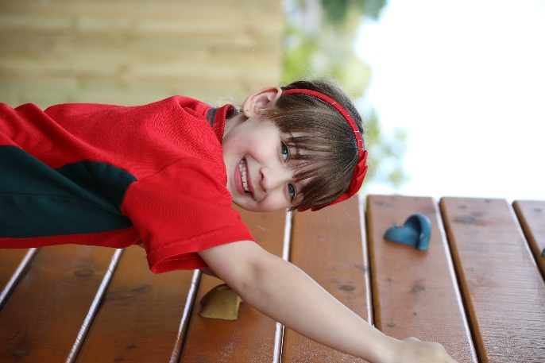
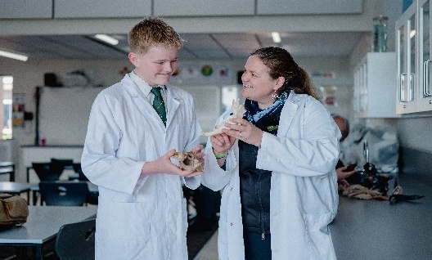
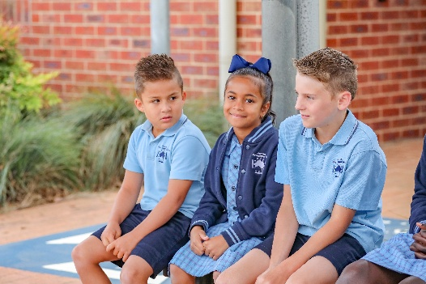
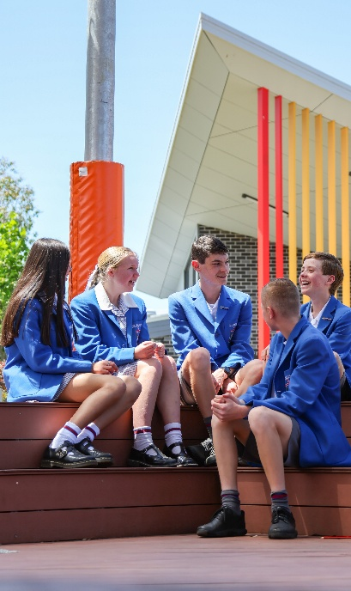
All: Amen.

Reflection on Peace
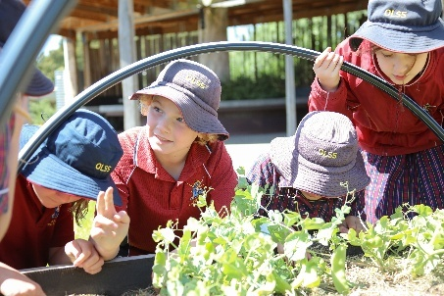
Reader: All people, everywhere in the world, deserve to have peace in their lives. As followers of Jesus, the Prince of Peace, we are called to be peacemakers, at home, in school, wherever we are. There is a famous prayer, written by St Teresa of Avila, which reminds us that Jesus uses us to spread his gospel of peace, in the way we live our everyday lives. Let us listen to the prayer.
Christ has no body now on earth but yours, no feet but yours.
Yours are the eyes - through which his love looks out to the world.
Yours are the feet - with which he goes about doing good.
Yours are the hands - with which he blesses people now.

Leader: In this quiet moment we pause to ask ourselves these questions:
- How can my eyes, the way I look at people, bring peace and love?
- How can I use my feet to do good and bring happiness and peace?
- How can I use my hands to bless and help and bring peace to those around me?


Reader: (re-reads the prayer)
Christ has no body now on earth but yours, no feet but yours.
Yours are the eyes - through which his love looks out to the world.
Yours are the feet - with which he goes about doing good.
Yours are the hands - with which he blesses people now.

Leader: Let us pray together for all those who don’t have peace in their lives:

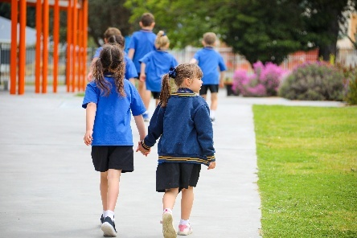
All: God of peace,
We pray for peace everywhere.
Where there is hatred, help us to sow seeds of calm.
Where there is destruction, help us to rebuild.
Where people are sad, helps us to support them.
Shelter your people and protect them.
Guide them and keep them from harm.
Help me to be a peacemaker at home, in school, wherever I am.
Amen.

OR

Leader: The Prayer of St Francis was not actually written by St Francis of Assisi but it strongly reflects his spirit of peace, love, faith, hope, light and joy. This prayer asks God to help us become people who bring peace to others. It teaches us to choose love, forgiveness, and kindness instead of anger, hurt, or selfishness. Saying this prayer helps us remember that small, caring actions can change someone’s day.

All: Lord, make me an instrument of your peace.
Where there is hatred, let me sow love;
where there is injury, pardon;
where there is doubt, faith;
where there is despair, hope;
where there is darkness, light;
and where there is sadness, joy.
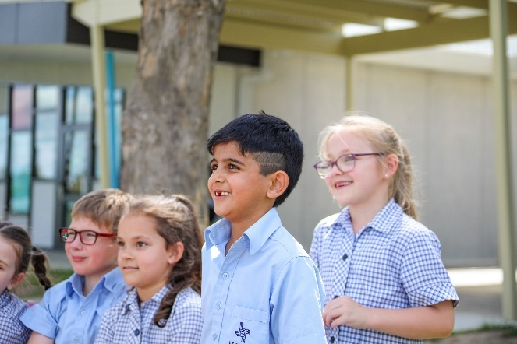
O Divine Master, grant that I may not so much seek to be consoled as to console;
to be understood as to understand;
to be loved as to love.
For it is in giving that we receive;
it is in pardoning that we are pardoned;
and it is in dying that we are born to eternal life. Amen.

OR

Leader: Make me a channel of your peace.
All: God wants me to make things better for others.

Leader: Where there is hatred, let me sow love.
All: If someone is mean, I will try to be kind instead of being mean back to them.
Leader: Where there is injury, pardon.
All: If someone hurts me, I will try to forgive and help to heal the friendship.
Leader: Where there is doubt, faith.
All: If someone is unsure or scared, I will help them to trust and feel brave.
Leader: Where there is despair, hope.
All: If someone feels sad, I will try to give them something to look forward to.
Leader: Where there is darkness, light.
All: If things feel gloomy, I will try to bring cheerfulness and truth.
Leader: Where there is sadness, joy.
All: If someone is unhappy, I will try to make them smile or laugh.
Leader: Not so much to be consoled as to console.
All: Instead of always wanting others to comfort me, I will comfort others.
Leader: Not so much to be understood as to understand.
All: I will try to listen to others before I want them to listen to me.
Leader: Not so much to be loved as to love.
All: I will try to love others first, even when it’s hard.
Think about how you can live this prayer every day. Perhaps you could…
- Do one small kind thing each day: share, help, or say something encouraging.
- Say sorry quickly when you hurt someone and try to fix it.
- Listen more when a friend talks instead of thinking about what you’ll say next.
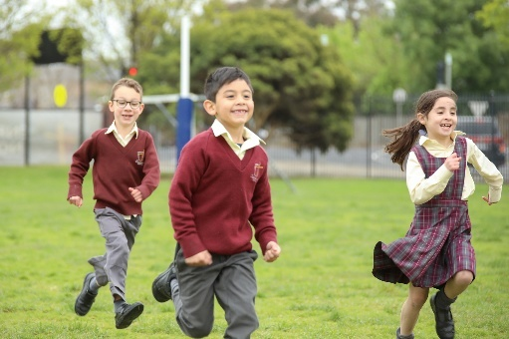
- Look for someone who’s alone and invite them to join you.

Peace challenge
Pick one line from the prayer each day and try to do one thing that
shows it.

Concluding Prayer

Leader: Lord Jesus, Prince of Peace, you make your home among us and call us to live as one family. Fill our hearts with your Spirit so that our school may be a true home of peace, welcome, respect, and reconciliation. Teach us to listen before we speak, to forgive before we judge, and to repair what is broken with courage and gentleness.
Bless our students, teachers, staff, families, and all who enter our school. Give us the wisdom to shape practices that protect everyone, the patience to form habits of kindness, and the generosity to serve our neighbours in word and deed. Where there is fear, bring your calm; where there is division, bring your healing; where there is indifference, let there be compassion.
May Mary, Mother of the Church, and all the saints who worked for peace, accompany us. May the Father who loves us, the Son who reconciles us, and the Holy Spirit who dwells within us keep this school a home of peace now and always.

All: Amen.

Recessional Song Suggestions

- ‘God be with you as you Go’ (Andrew Chinn, 2015 on In Joyful Hope)
- ‘A Time to Start Over’ (John Burland, 2025)
- ‘What a Friend We Have in Jesus’ (Matt Maher)
- ‘Inspired to Serve’ (Judy Bailey, 2003 on Surrounded)
- ‘Send Us Out’ (Gen Bryant, 2017)
- ‘Go Out’ (Drew Lane, 2020, on Song of the Spirit)
- ‘Go Now in Peace ‘(Andrew Chinn, 2014 on Together as One, Vol. 1 or This Day)
- ‘Joyful Generation’ (Timothy Hart, 2017)
- ‘Do what Jesus did’ (Michael Mangan, 2014 on 1,2,3, God Loves Me)
- Glory (Let There be Peace) (Matt Maher, 2016)

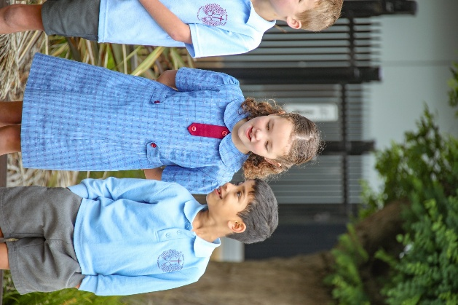
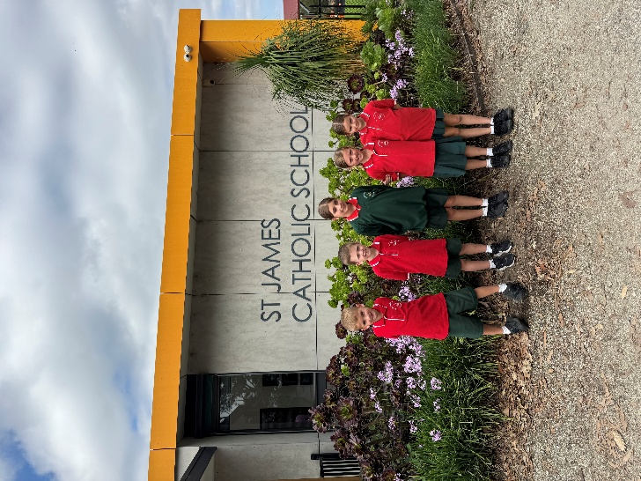

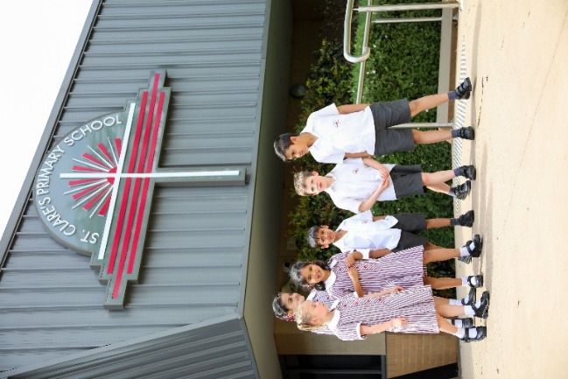

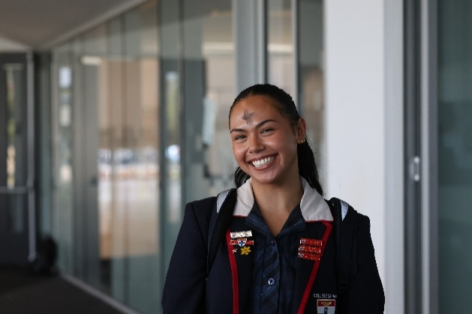
Alternative Scripture Texts

A Reading from the prophet Isaiah (26: 3-4)
Those of steadfast mind you keep in peace—
in peace because they trust in you.
Trust in the Lord forever,
for in the Lord God
you have an everlasting rock.

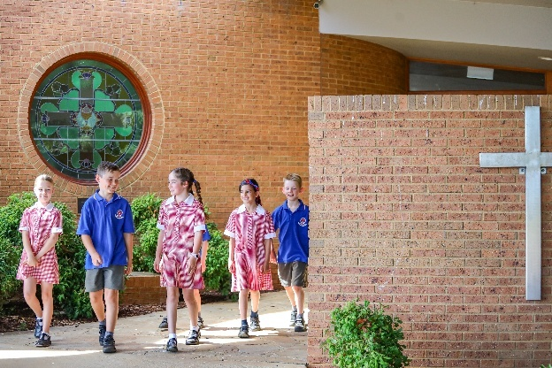
The Word of the Lord.
All: Thanks be to God.

OR

A Reading from the prophet Isaiah (54:10)
For the mountains may depart
and the hills be removed,
but my steadfast love shall not depart from you,
and my covenant of peace shall not be removed,
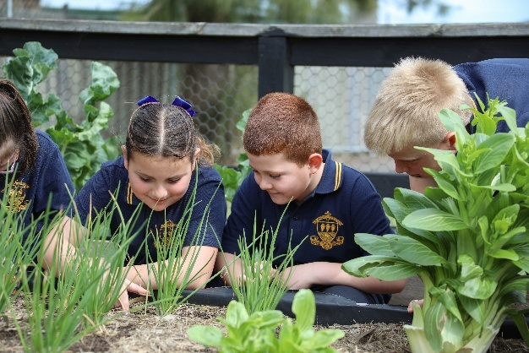
says the Lord, who has compassion on you.

The Word of the Lord.
All: Thanks be to God.

OR

Responsorial Psalm (Psalm 29:1-2, 3-4, 3, 9-10)

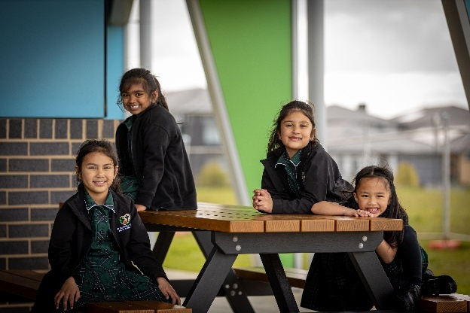
R. The Lord will bless his people with peace.
Give to the Lord, you sons and daughters of God,
give to the Lord glory and praise,
Give to the Lord the glory due his name;
adore the Lord in holy attire.
R. The Lord will bless his people with peace.

The voice of the Lord is over the waters,
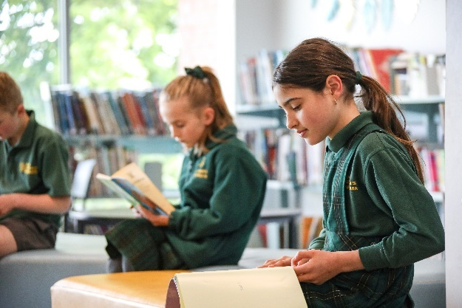
the Lord, over vast waters.
The voice of the Lord is mighty;
the voice of the Lord is majestic.
R. The Lord will bless his people with peace.
The God of glory thunders,
and in his temple all say, “Glory!”
The Lord is enthroned above the flood;
the Lord is enthroned as king forever.
R. The Lord will bless his people with peace.

OR
A reading from the Holy Gospel according to Matthew (5:1-12)
When Jesus saw the crowds, he went up the mountain; and after he sat down, his disciples came to him. Then he began to speak, and taught them, saying:
“Blessed are the poor in spirit, for theirs is the kingdom of heaven.
“Blessed are those who mourn, for they will be comforted.
“Blessed are the meek, for they will inherit the earth.
“Blessed are those who hunger and thirst for righteousness, for they will be filled.
“Blessed are the merciful, for they will receive mercy.
“Blessed are the pure in heart, for they will see God.
“Blessed are the peacemakers, for they will be called children of God.
“Blessed are those who are persecuted for righteousness’ sake, for theirs is the kingdom of heaven.
“Blessed are you when people revile you and persecute you and utter all kinds of evil against you falsely on my account. Rejoice and be glad, for your reward is great in heaven, for in the same way they persecuted the prophets who were before you.
The Gospel of the Lord
All: Praise to you, Lord Jesus Christ.

Commentaries, Homilies and Reflections for this text can be found on Liturgy Help on the Fourth Sunday in Ordinary Time, Year A (Sunday 1 February 2026) Background information on this text can be found on the NCEC Scripture resource

OR

A reading from the Holy Gospel according to John (14: 27)
Peace I leave with you; my peace I give to you. I do not give to you as the world gives. Do not let your hearts be troubled, and do not let them be afraid.
The Gospel of the Lord
All: Praise to you, Lord Jesus Christ.

OR

A Reading from the Second Letter to the Thessalonians (3:16)
Now may the Lord of peace himself give you peace at all times in all ways. The Lord be with all of you.
The Word of the Lord.
All: Thanks be to God.

OR

A Reading from the Letter to the Colossians (3:14-15)
Above all, clothe yourselves with love, which binds everything together in perfect harmony. And let the peace of Christ rule in your hearts, to which indeed you were called in the one body. And be thankful.
The Word of the Lord.
All: Thanks be to God.

OR

A Reading from the Letter to the Galatians (5: 22-23)
The fruit of the Spirit is love, joy, peace, patience, kindness, generosity, faithfulness, gentleness, and self-control.
The Word of the Lord.
All: Thanks be to God.

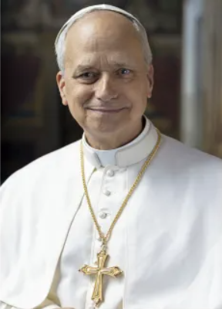
Some Words from Pope Leo

- Peace be with you all! Dear brothers and sisters, these are the first words spoken by the risen Christ, the Good Shepherd who laid down his life for God’s flock. I would like this greeting of peace to resound in your hearts, in your families, among all people, wherever they may be, in every nation and throughout the world. Peace be with you! It is the peace of the risen Christ. A peace that is unarmed and disarming, humble and persevering. A peace that comes from God, the God who loves us all, unconditionally. (First Blessing of His Holiness Pope Leo XIV: 8 May 2025)

- Peace is not a spiritual utopia: it is a humble path, made up of daily gestures that interweave patience and courage, listening and action, and which demands today, more than ever, our vigilant and generative presence. (Journey with the Pope: 21 October 2025)

- Conflicts are present in all parts of life, but war is no help in dealing with them or finding solutions. Peace is a constant journey of reconciliation. (Journey with the Pope: 1 November 2025)

- We share the desire for peace for all peoples. We are the voice of those who are not heard and the voiceless. We must “dare peace!” (Journey with the Pope: 10 November 2025)

- Today the whole of society needs that jolt, it needs your witness and the great work you are doing. Indeed, we all have the vocation to be freer and to be human, the vocation to peace. This is the most divine vocation. (Journey with the Pope: 11 November 2025)

- The path to peace demands hearts and minds trained in concern for others and capable of perceiving the common good in today’s world. For the road to peace involves everyone and leads to the fostering of right relationships between all living beings. (Journey with the Pope: 19 November 2025)

- Peace, must be pursued with prayer, acts of penance, contemplation and nurturing a living relationship with the Lord, who helps us to discern what words, gestures and actions to undertake so that we can genuinely be at the service of peace. (At the Armenian Apostolic Cathedral of Istanbul, Turkey, 30 November 30 2025)

- Peace exists; it wants to dwell within us. It has the gentle power to enlighten and expand our understanding; it resists and overcomes violence. Peace is a breath of the eternal: while to evil we cry out “Enough,” to peace we whisper “Forever.” … Peacemakers continue to resist the spread of darkness, standing as sentinels in the night… Saint Augustine urged Christians to forge an unbreakable bond with peace, so that by cherishing it deeply in their hearts, they would be able to radiate its luminous warmth around them. Addressing his community, he wrote: “If you wish to draw others to peace, first have it yourselves; be steadfast in peace yourselves. To inflame others, you must have the flame burning within.” … Dear brothers and sisters, whether we have the gift of faith or feel we lack it, let us open ourselves to peace! Let us welcome it and recognize it, rather than believing it to be impossible and beyond our reach. Peace is more than just a goal; it is a presence and a journey. Even when it is endangered within us and around us, like a small flame threatened by a storm, we must protect it, never forgetting the names and stories of those who have borne witness to it. Peace is a principle that guides and defines our choices. Even in places where only rubble remains, and despair seems inevitable, we still find people who have not forgotten peace. Just as on the evening of Easter Jesus entered the place where his disciples were gathered in fear and discouragement, so too the peace of the risen Christ continues to pass through doors and barriers in the voices and faces of his witnesses. This gift enables us to remember goodness, to recognize it as victorious, to choose it again, and to do so together… Although many people today have hearts ready for peace, they are often overcome by a great sense of powerlessness before an increasingly uncertain world. Saint Augustine had already pointed out this particular paradox: “It is not difficult to possess peace; it is, perhaps, more difficult to praise it. To praise peace, we may find that we lack the necessary talent; we search for the right ideas and weigh our words. But to have peace, it is there, within reach, and we can possess it without effort.”… And yet, “those who truly love peace also love the enemies of peace.” Saint Augustine thus advised not to burn bridges or persist in reproach, but to prefer listening and, where possible, engaging in discussions with others... Therefore, alongside action, it is more necessary than ever to cultivate prayer, spirituality, and ecumenical and interreligious dialogue as paths of peace and as languages of encounter within traditions and cultures. Throughout the world, it is to be hoped that “every community become a ‘house of peace,’ where one learns how to defuse hostility through dialogue, where justice is practiced and forgiveness is cherished.” (Message of His Holiness Pope Leo XIV for the LIX World Day of Peace: 1 January 2026)

- Peace is built on respect for peoples! Be peacemakers at home, at school, in sports, everywhere. Never be violent, neither with words nor with gestures. Never! Evil can only be overcome with good. (25 January 2026)

- Peace begins with the recognition and protection of the God-given dignity of every person. (1 March 2026)

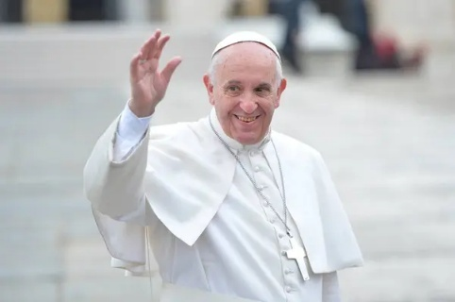
Some Words from Pope Francis

- Be pilgrims of hope and builders of peace. (20 March 2024)

- Christian pilgrimage means keeping our eyes, minds, and hearts fixed on our goal—which is Christ—and set out every day anew. Our pilgrimage on this earth is far from a pointless journey or aimless wandering. On the contrary, each day, by responding to God’s call, we try to take every step needed to advance towards a new world where people can live in peace, justice, and love. (21 April 2024)

- Our life finds fulfilment when we discover who we are, what our gifts are, where we can make them bear fruit, and what path we can follow in order to become signs and instruments of love, generous acceptance, beauty, and peace, wherever we find ourselves. (21 April 2024)

- We are living in a time of great need for light, for hope, and a need for peace in which people at times create situations so complicated that it seems impossible to get out of them. God never stops. God finds a thousand ways to reach everyone, each and every one of us, wherever we are, without calculation and without conditions, opening even in the darkest nights of humanity windows of light that the darkness cannot obscure. (5 January 2025)

- Always, peace is possible! We have to seek it…. Prayer is the very root of peace. Peace is always possible and our prayer is at the root of peace. Prayer disseminates peace. (World Day of Peace, 2025)

- Let us pray for peace: peace in the world and in each of our hearts. God's love calls us to move beyond fear. We ask God for the courage to put on faith, hope and love as we go out into the world and become the word in body as well as spirit. (in ‘First belong to God. On retreat with Pope Francis’ by Austen Iverleigh, 2024)

- May 2025 be a year in which peace flourishes! A true and lasting peace that goes beyond quibbling over the details of agreements and human compromises. May we seek the true peace that is granted by God to hearts disarmed: hearts not set on calculating what is mine and what is yours; hearts that turn selfishness into readiness to reach out to others; hearts that see themselves as indebted to God and thus prepared to forgive the debts that oppress others; hearts that replace anxiety about the future with the hope that every individual can be a resource for the building of a better world. (World Day of Peace, 2025, para. 13)

- Disarming hearts is a job for everyone, great and small, rich and poor alike. At times, something quite simple will do, such as “a smile, a small gesture of friendship, a kind look, a ready ear, a good deed”. With such gestures, we progress towards the goal of peace. We will arrive all the more quickly if, in the course of journeying alongside our brothers and sisters, we discover that we have changed from the time we first set out. Peace does not only come with the end of wars but with the dawn of a new world, a world in which we realize that we are different, closer and more fraternal than we ever thought possible. (World Day of Peace, 2025, para. 14)

Some Words from Pope John Paul II (now Saint John Paul II)

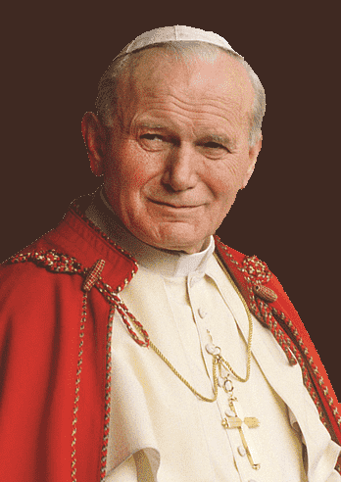
To reach peace, teach peace. (For the Celebration of the Day of Peace, 1/1/1979)

No peace without justice, no justice without forgiveness ... Peace is essential for development, but true peace is made possible only through forgiveness. (For the Celebration of the Day of Peace, 1/1/2002)

Some Words from Pope Paul VI (now Saint Paul VI)
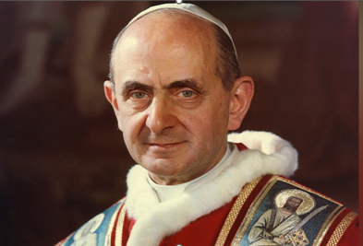
Education is a path to peace is at the heart of St Paul VI's Encyclical Letter. Populorum Progressio [The Development of Peoples], 26/3/1967.

If you want peace, work for justice. (For the Celebration of the Day of Peace, 1/1/1972)

Some Words from Pope John XXIII (now Saint John XXIII)

The world will never be the dwelling place of peace, till peace has found a home in the heart of each and every person. (Pacem in Terris [Peace on Earth], 1963, para. 165)
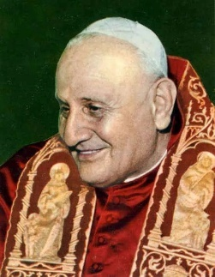

Some Words from Others

- Peace is not the absence of conflict; it is the ability to handle conflict by peaceful means. (Ronald Reagan)

- If we have no peace, it is because we have forgotten that we belong to each other. (Saint Teresa of Calcutta)

- Peace begins with a smile. (Saint Teresa of Calcutta)

- All works of love are works of peace. (Saint Teresa of Calcutta)

- Peace comes from being able to contribute the best that we have, and all that we are, toward creating a world that supports everyone. But it is also securing the space for others to contribute the best that they have and all that they are. (Hafsat Abiola)

- Building peace is more often about creating space, developing relationships, persevering in spite of overwhelming pessimism, and being flexible enough to respond to emerging opportunities. (John Paul Lederach)

- We live now in a global village and we are in one single family. It’s our responsibility to bring friendship and love from all different places around the world and to live together in peace. (Jackie Chan)

- When the power of love overcomes the love of power the world will know peace. (Jimi Hendrix)

- There is no trust more sacred than the one the world holds with children. There is no duty more important than ensuring that their rights are respected, that their welfare is protected, that their lives are free from fear and want and that they grow up in peace. (Kofi Annan)

- Community responsibility, when it is managed well, results in peace. And peace benefits everyone. Taking care of someone or something to which you are not immediately genetically related pays you back in other dimensions, and the payback is part of your wellbeing. Compassion is useful and beneficial for all. (Katy Payne)

- Peace does not mean an absence of conflicts; differences will always be there. Peace means solving these differences through peaceful means; through dialogue, education, knowledge; and through humane ways. (The 14th Dalai Lama)

- Peace is not just the absence of conflict; peace is the creation of an environment where all can flourish, regardless of race, colour, creed, religion, gender, class, caste, or any other social markers of difference. (Nelson Mandela)

- Without deep listening and gentle loving speech it is very difficult to move towards peace. (Thich Nhat Hanh)

- Peace is not something you must hope for in the future. It is a deepening of the present, and unless you look for it in the present, you will never find it. (Thomas Merton)

- It isn’t enough to talk about peace. One must believe in it. And it isn’t enough to believe in it. One must work at it. (Eleanor Roosevelt)

- First keep peace with yourself, then you can also bring peace to others. (Thomas Kempis)

- Make peace with the universe. Take joy in it. It will turn to gold. Resurrection will be now. Every moment, a new beauty. (Jalal ad-Din Muhammad Rumi)

- If there is to be peace in the world, there must be peace in the nations. If there is to be peace in the nations, there must be peace in the cities. If there is to be peace in the cities, there must be peace between neighbors. If there is to be peace between neighbors, there must be peace in the home. If there is to be peace in the home, there must be peace in the heart. (Lao Tzu)

- Let there be peace on earth… and let it begin with me. (Jill Jackson and Sy Miller)

- Nothing is more precious than peace. Peace is the most basic starting point for the advancement of humankind. (Daisaku Ikeda)

- If you want to make peace, you don’t talk to your friends. You talk to your enemies. (Moshe Dayan)

- Lord, make me an instrument of thy peace. Where there is hatred, let me sow love. (St Francis of Assisi)

- The most valuable possession you can own is an open heart. The most powerful weapon you can be is an instrument of peace. (Carlos Santana)

- You cannot shake hands with a clenched fist. (Indira Ghandi)

Laudato Si’ Week 2026 ~ 17 - 24 May

Theme – From Hope to Action
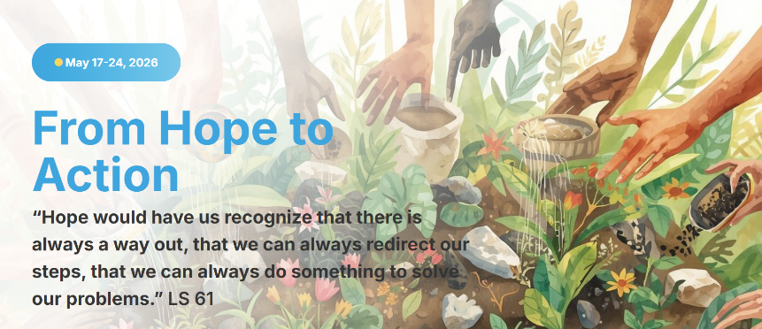

National Reconciliation Week 2026 ~ 27 May - 3 June
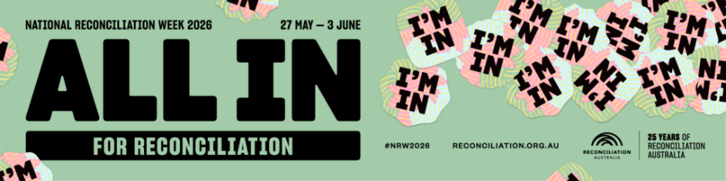

National Reconciliation Week (NRW) is a time for all Australians to learn about our shared histories, cultures, and achievements, and to explore how each of us can contribute to achieving reconciliation in Australia.
The theme for National Reconciliation Week 2026 is All In, a call for all Australians to commit wholeheartedly to reconciliation every single day.
All In makes clear that reconciliation is not a spectator sport and that all of us must step away from the sidelines and take action to make change.

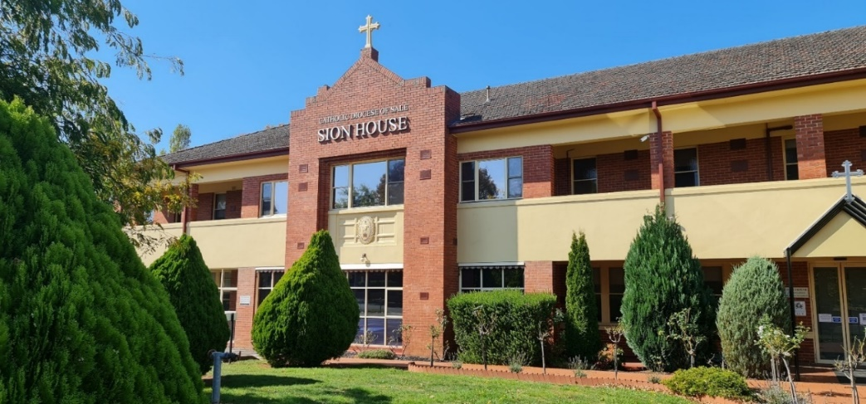
Sion House, Warragul

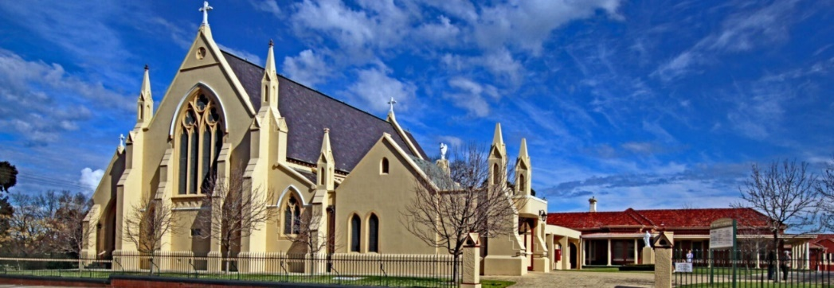
St Mary’s Cathedral, Sale

Rapping Out a Call for Peace
Alice Youlden
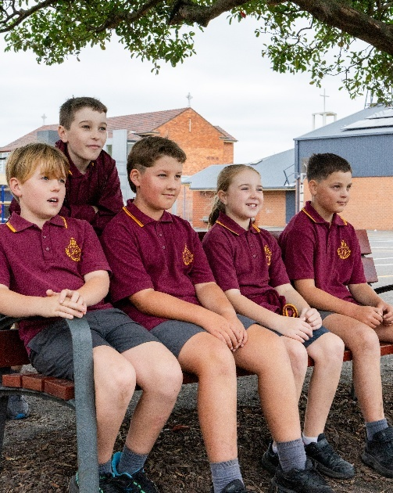
You’ve heard about the theme for Cath Ed Week,
In this year of peace, it is peace we seek.
If we want every school to be a home of peace,
Actions are needed, and elbow grease.

If we want peace to spread like a ripple in a pond
Then it starts in our heart moving far, far beyond.
We all want peace, but it takes some work,
So, the cry is going out ‘don’t hide, don’t shirk’.

The first thing to do is just slow down,
Take time to think before running people down.
It is not cool to make others live in fear,
Don’t laugh at them or hurt with a put down or a sneer.

We need to remember that in every human being,

There’s a spark of God that we must all be seeing.
We may not agree with all that people say,
Opinions may differ but that’s ok.

We really must be open to others we meet,
It’s the simple things that matter such as how we greet.
Respecting others’ feelings, being humble and forgiving,
Listening, showing mercy, that’s how we should be living.

Kindness and love spread further than hate,
For the world needs young people to stand up don’t wait.
Sometimes it takes courage, it may not seem so cool
To go against a group who might think you’re a fool.

Little acts of kindness show the way to peace,
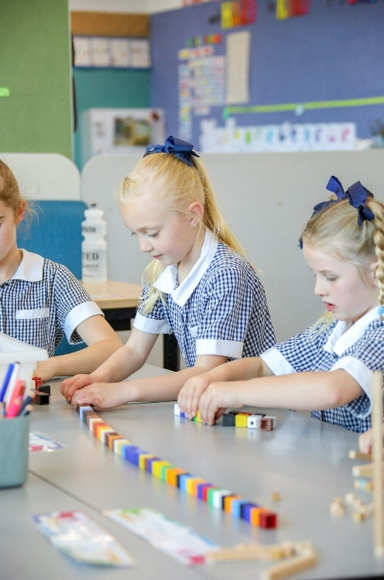
It might mean saying sorry to make the anger cease.
The prayer of St Francis just says it all,
Pope Leo is right you must answer the call.

Every school a home of peace that is the aim,
So, get with it, say some prayers, build peace, it’s not a game.
Take the time to reflect on the things that you do,
You can change, show the way for others to follow too.

Build peace, that’s a rap that you’re invited to.



